MAT 243 Project Three Summary Report

Kyle Payne
Kyle.payne2@snhu.edu
Southern New Hampshire University

1. Introduction
The cleaned FiveThirtyEight NBA Elo data set records six hundred eighteen team seasons between 1995 and 2015. For each season it lists the total regular season wins and four performance measures:
- Average points scored per game
- Average Elo rating that measures overall skill
- Average point differential, which is the mean margin of victory or loss
- Average Elo differential, which is the game-by-game difference in Elo between the team and its opponents
The coaching staff wants a reliable equation that converts these measures into an expected number of wins. Such an equation lets them set numerical goals, evaluate trades, and watch early warning signals during the season. I use scatterplots and Pearson correlations for initial exploration, then fit one simple linear regression and two multiple linear regression models to see how well these measures predict wins.

2. Data Preparation
- avg_pts_differential – tells by how many points a team usually outscores or is outscored by an opponent in one game. A value of five means that the team wins each game by about five points on average.
- avg_elo_n - is the season long average of the Elo number which is calculated by FiveThirtyEight. Elo rises after results that beat expectation and falls after results that miss expectation, so bigger values signal stronger teams.

3. Simple Linear Regression: Scatterplot and Correlation for the Total Number of Wins and Average Relative Skill
Data visualization lets us look for patterns long before we calculate any numbers. A scatterplot is the most direct tool for two variables because each dot marks one paired observation; the overall tilt of the cloud shows the direction, the tightness of the cloud shows strength, and any dots far from the rest warn us about unusual seasons that may need further checking.
To turn the picture into a single measure we compute the Pearson correlation coefficient. This statistic always falls between negative one and positive one. The sign tells us whether the pattern rises or falls, and the size tells us how tightly the dots cling to an imaginary straight line. A value near positive one means a strong rising trend and near zero means almost no linear trend.
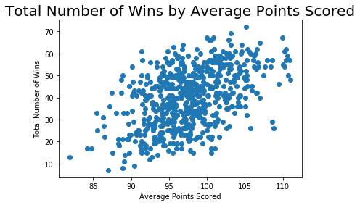
The scatterplot above shows a clear rising band. The Pearson correlation is 0.9072 and the p-value rounds to 0.0000. the large positive value confirms that teams with higher average relative skill almost always have more wins, and the p-value is far below the one percent significance level, so this strong relationship is statistically real rather than random noise.

4. Simple Linear Regression: Predicting the Total Number of Wins using Average Relative Skill
A simple linear regression draws a single straight line that minimizes the total squared distance between observed points and the line itself. Once that line is set, we can plug any value of the predictor into the equation and get a predicted value of the response. Here the response is the total number of regular season wins and the predictor is the average relative skill (Elo). The equation is:

Predicted Wins = -128.25 + 0.1121(Average relative skill)
To decide whether this model is useful we test the null hypothesis that the slope equals zero.
Table 1: Hypothesis Test for the Overall F-Test
Statistic | Value
Test Statistic | 2865.00
P-value | 0.0000

Null hypothesis H₀: β₁ = 0 (the average relative skill doesn’t predict wins)
Alternative hypothesis H_{a}: β₁ ≠ 0 (average relative skill does predict wins)
Level of significance (alpha) = 5%

Because the p-value is far below the five percent we reject the null hypothesis H₀. The very large test statistic and the coefficient of determination (R² = 0.823) confirm that the model explains 82% of the season-to-season variation in wins.
Predictions:
- A team with an average relative skill of 1550 is expected to win 45 games.
- A team with an average relative skill of 1450 is expected to win 34 games.
These estimates show that raising season-long Elo by one hundred points projects about eleven extra victories. This gives the coach a clear numeric target for skill development.

5. Multiple Regression: Scatterplot and Correlation for the Total Number of Wins and Average Points Scored
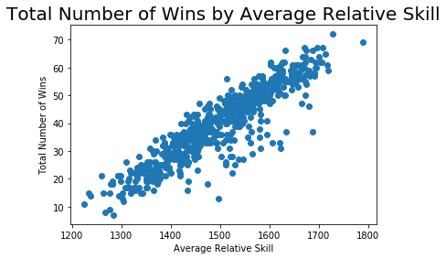
The above scatterplot lets us see how wins change as scoring rises. The points form a loose upward cloud, so any relationship is present but not tight. The Pearson correlation for these two variables is 0.4777 and the p-value rounds to 0.0000. This value tells us that teams that score more points tend to win more games, but the link is only moderate compared with the very strong average Elo relationship seen earlier. Because the p-value is far below the one percent significance level, the correlation is statistically significant, meaning the upward trend we see in the plot is almost certainly not due to random chance.

6. Multiple Regression: Predicting the Total Number of Wins using Average Points Scored and Average Relative Skill
A multiple linear regression builds one equation that lets two or more predictors work together to estimate the response. Each slope shows the separate effect of one predictor after the other are held fixed, and the overall F-test checks whether the model explains a meaningful part of the variation in the response. The equation is:

Predicted Wins = -152.574 + 0.3497(average points scored) + 0.1055(average relative skill)
Table 2: Hypothesis Test for the Overall F-Test
Statistic | Value
Test Statistic | 1580
P-value | 0.0000

Null hypothesis H₀: β₁ = β₂ = 0 (neither predictor helps explain wins)
Alternative hypothesis H_{a}: at least one of the parameters β differs from zero
Level of significance (alpha) = 5%

Because the p-value is far below the five percent, we reject the null hypothesis H₀. At least one predictor is useful. Individual t-tests confirm that average points (t=7.297, p-value < 0.01) and the average relative skill (t=47.952, p-value < 0.01) are each significant at the one percent level.
The coefficient of determination is R² = 0.837, so about 84% of the season-to-season variation in wins is explained by the two predictors together. Average relative skill remains the stronger factor, but average points also adds predictive value when both are included.
Predictions:
- A team that scores 75 points per game and has a relative skill of 1350 is expected to win 16 games.
- A team that scores 100 points per game and has a relative skill of 1600 is expected to win 51 games.
These results tell the coach that lifting either scoring or relative skill can raise the win total, but improving relative skill has the larger impact per unit change.

7. Multiple Regression: Predicting the Total Number of Wins using Average Points Scored, Average Relative Skill, Average Points Differential, and Average Relative Skill Differential
A multiple linear regression combines several predictors in one equation, letting each slope describe the unique effect of its variable while others are held fixed. This approach is most useful when no single measure tells the whole story. The equation is:

Predicted Wins = 34.5753 + 0.2597(average points scored) – 0.0134(average relative skill) + 1.6206(average point differential) + 0.0525(average relative skill differential)

Table 3: Hypothesis Test for Overall F-Test
Statistic | Value
Test Statistic | 1102.00
P-value | 0.0000

Null hypothesis H₀: β₁ = β2 = β3 = β4 = 0 (the four slopes are zero, so none of the predictors explains wins)
Alternative hypothesis H_{a}: at least one β₁ differs from zero.
Level of significance (alpha) = 5%

The p-value is far below five percent, so we reject the null hypothesis H₀. The model is useful, and at least one predictor is linked to changes in wins
Significance of each predictor:
- Average points scored (t = 6.070, P = 0.0000) is significant.
- Average relative skill (t = -0.769, P = 0.4422) is not significant.
- Average point differential (t = 12.024, P = 0.0000) is significant.
- Average relative skill differential (t = 2.915, P = 0.0040) is significant.
The coefficient of determination (R²) is 0.878, so the four variable model explains almost 88% of the season-to-season variation in wins, the best fit of all the models tested.
Predictions:

- Team averaging 75 points, relative skill of 1350, point differential of -five, and a relative skill differential of -30 is expected to win 26 games.
- Team averaging 100 points, relative skill of 1600, point differential of five, and a relative skill differential of 95 is expected to win 52 games.

These results show that widening the scoring margin and the relative skill margin has the strongest impact on season wins, while the separate effect of average points is smaller and the separate effect of average skill disappears once the two differential measures are in the equation.

8. Conclusion
The statistics show a clear story. Average relative skill by itself already explains more than four fifths of the differences in season wins. Adding average points gives only a small lift, while adding point differential and skill differential pushes the model to almost 88% percent accuracy. Point differential is the strongest single lever: every extra point of average margin raised the expected win total by about one and a half. Skill differential is the next most powerful. Average points and average skill have smaller separate effects once the differentials are in the equation.
For coaches and managers, these findings turn into direct actionable steps. First, focus practices and player development on widening the scoring gap, because even a small change in margin translates into several more victories. Second, track point differential and skill differential after every game; if either measure slips, intervene quickly with a possible lineup changes or strategy adjustments. Third, when considering trades or signings, estimate how each candidate will shift the team’s differentials rather than looking at raw scoring. By using the regression equations as an everyday tool, the organization can make choices that are tied to a quantified gain in wins, moving from intuition to data driven planning.

References

FiveThirtyEight. (2019). FiveThirtyEight NBA Elo dataset [Data set]. Kaggle

